MGMS – Asset Purchase

Functional Specification Document
Ver. 1.4

Version History
Version # | Date | Description
1.0 | 15-Oct-2010 | First Draft
1.1 | 25-Oct-2010 | Updated the Status Messages section
1.2 | 15-Nov-2010 | Added new validations

Table of Contents

Version History 2
1 Introduction 4
1.1 Purpose 4
1.2 Scope 4
1.3 Assumptions 4
1.4 Constraints 4
2 Asset Management 5
2.1 Current Projects List 5
2.2 Project Item Purchase 6
2.3 Edit Item Purchase 7
3 Business Rules 8
4 Status Messages 8

Introduction

Purpose

This document provides the requirements and functional specifications for the Asset Purchase module of the Multisite Grant Management System project.
This is not a project plan or a design document. It is a guide for system architecture and development, not for phasing, timelines or deliverables.
Finally, this is a ‘living document’ and the specification will change, continuously, as the project proceeds. More details will be added and the existing information edited as the requirements, scenarios and use cases evolve in the course of the project.

Scope

The current features shall enable the user to record for a specific project, the purchases made each associated with a specific item code, order no:, received date, bill no:, total cost and user’s remarks, if any.
Future functionalities (scope) would capture item details such as number of units, per unit price, tax involved and the specific account head paying for it. Provision will be made for upload and viewing external bills, invoices, purchase orders etc. As mentioned these can be expected only in upcoming releases.

Assumptions

Currently, the purchase details can be captured free of all validations related to intention of purchase. It is assumed that each set purchase detail (the combo of bill no: order no: and received date) are associated with solely one project and also multiple records may be created for the same item in the order.

Constraints

As a proper detailed accounting module is envisaged for the project, the definite dependency that will arise then is giving pause to the development of this module at the moment.

Asset Management

In Asset Management module, equipment purchase details can be recorded against each project.

For each purchase, details saved include: item name, asset code, order no:, received date, bill no:, cost and user’s remarks, if any.

Clicking on the Asset Management menu on the left panel will open the Current Projects list screen, as shown below:

Current Projects List
Figure 1: Current Projects List
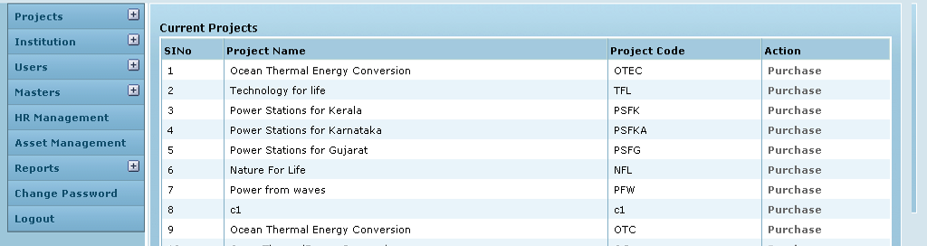

Screen & Control Description

Field /Label | Input-Control | Data Type | Details
Sl No | Auto generated sequential numbering for each row
Project Name | Auto populated | String
Project Code | Auto populated | String
Action | “Purchase” link | link | Opens a new page – Project Item Purchase where the user can enter details of each purchase made.

Clicking on Purchase for a particular project will open the Project Item Purchase screen as shown below:

Project Item Purchase

Figure 2: Project Item Purchase
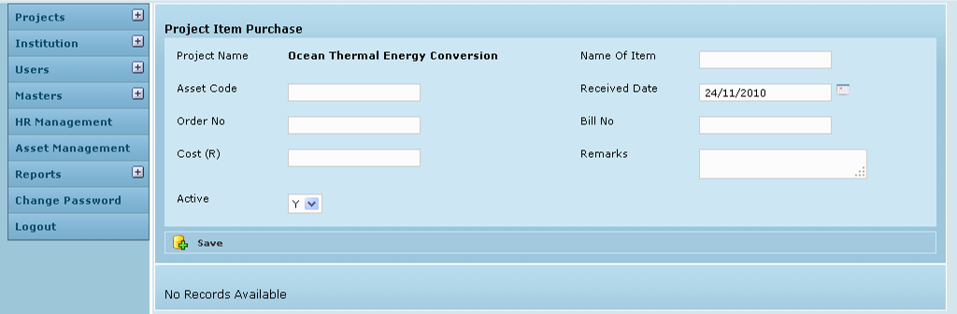

Screen & Control Description

Field /Label | Input-Control | Data Type | Details
Project Name | Auto populated | String
Name of item | Textbox | String | Required
Asset Code | Textbox | String | Required
Received Date | Calendar | datetime | Required. Default – current date. Format – dd/mm/yyyy
Order No: | Textbox | String | Required
Bill No: | Textbox | String | Required
Cost | Textbox | String | Required
Remarks | Text area | String | Optional
Save | Button |  | Saves the record. The screen is refreshed with a message – “Created Successfully” and the details are displayed in table format as shown in the screen below:

(When there are no saved records, a message is displayed on the screen as shown above – “No records available”)

Figure 3: Item Purchase - Success message
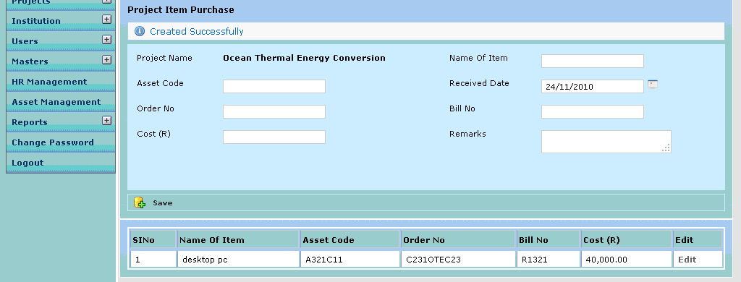

Field /Label | Input-Control | Data Type | Details
Sl No | Auto increment sequential
Name of item | Auto populated | String
Asset Code | Auto populated | String
Order No: | Auto populated | String
Bill No: | Auto populated | String
Cost | Auto populated | String
Edit | “Edit” | Link | System opens the edit screen , where the details of the particular line item purchase is already populated

Clicking on Edit for a particular purchase item line in the table will open the Edit Item Purchase screen as shown below:

Edit Item Purchase

Figure 4: Edit Item Purchase
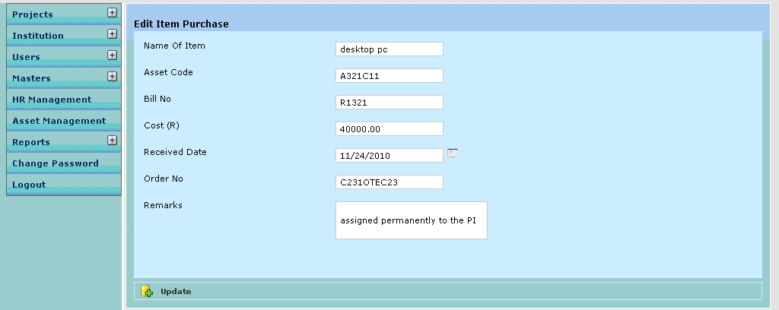

Screen & Control Description

Field /Label | Input-Control | Data Type | Details
Project Name | Auto populated
Name of item | Auto populated editable textbox | String | Required
Asset Code | Auto populated editable textbox | String | Required
Received Date | Auto populated editable calendar | datetime | Required
Order No: | Auto populated editable textbox | String | Required
Bill No: | Auto populated editable textbox | String | Required
Cost | Auto populated editable textbox | String | Required
Remarks | Auto populated editable textarea | String | Optional
Update | Button |  | Updates the record

Business Rules

- Negative amounts are not allowed.

Status Messages

Sl No | Status Messages
1 | Created Successfully
2 | Updated Successfully
3 | Deleted Successfully
4 | The Requested Record Not Found
5 | The Record can't be deleted, Already in use
6 | The Record Already Exists
7 | Please Enter order No
8 | Please Enter cost
9 | Please Enter Proper cost
10 | Please Enter asset code
11 | Please enter Proper Amount
12 | Invalid Cost

